
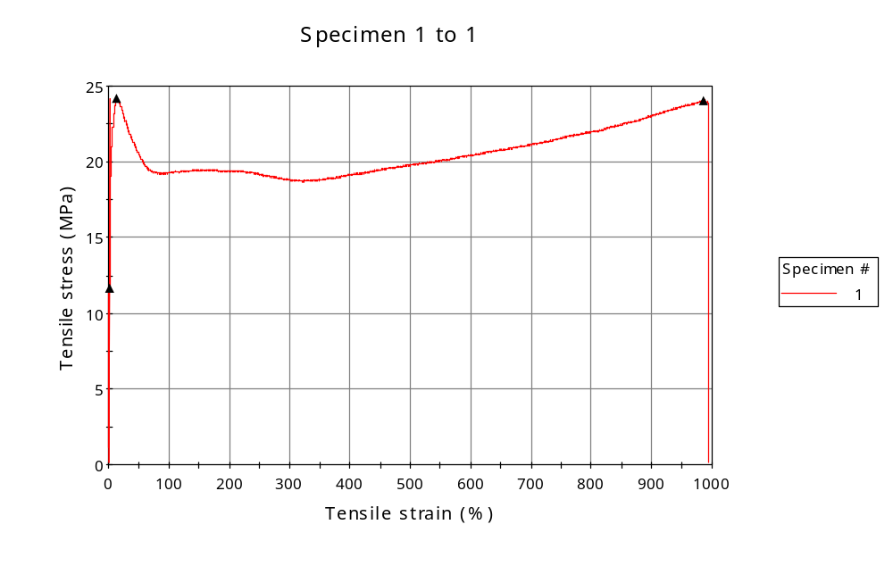
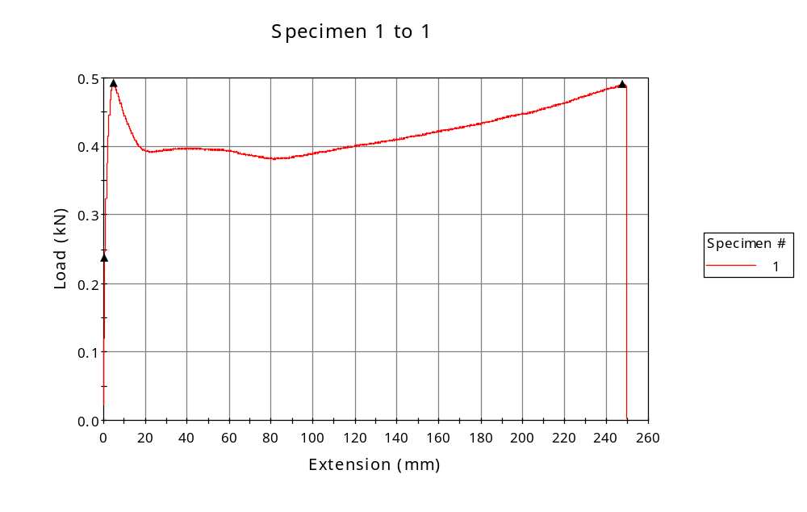

 | CP ID | Length  (mm) | Width  (mm) | Thickness  (mm) | Modulus (Automatic Young's)  (MPa)
1 | CP-PP_01 | 25.00 | 6.80 | 3.00 | 1519
Maximum |  | 25.00 | 6.80 | 3.00 | 1519
Minimum |  | 25.00 | 6.80 | 3.00 | 1519

 | Load at Fy ( 0.2 %) - LE  (kN) | Tensao em Fy ( 0.2 %) - LE  (MPa) | Deformacao em Fy ( 0.2 %) - LE  (%) | Forca Max  (kN) | Tensao na Forca Max - LR  (MPa)
1 | 0.237 | 12 | 0.968 | 0.492 | 24
Maximum | 0.237 | 12 | 0.968 | 0.492 | 24
Minimum | 0.237 | 12 | 0.968 | 0.492 | 24

 | Deformacao na Forca Max - LR  (%) | Forca na Forca na Quebra - LQ  (kN) | Deformacao na Forca na Quebra - LQ  (%) | Final length  (mm) | Final width  (mm)
1 | 14.032 | 0.491 | 986.365 | 119.00 | 6.82
Maximum | 14.032 | 0.491 | 986.365 | 119.00 | 6.82
Minimum | 14.032 | 0.491 | 986.365 | 119.00 | 6.82

 | Alongamento
1 | 3.76
Maximum | 3.76
Minimum | 3.76

